**Assignment-11.3:**

Write a Pig UDF To find the tweets posted by @realDonaldTrump from the given dataset

Column 1: id

Column 2: handle

Column 3: text

Column 4: is_retweet

Column 5: original_author

Column 6: time

Column 7: in_reply_to_screen_name

Column 8: in_reply_to_status_id

Column 9: in_reply_to_user_id

Column 10: is_quote_status

Column 11: lang

Column 12: retweet_count

Column 13: favorite_count

Column 14: Longitude

Column 15: Latitude

Column 16: Place_id

Column 17: Place_full_name

Column 18: Place_name

Column 19: Place_type

Column 20: Place_country_code

Column 21: Place_country

Column 22: Place_contained_within

Column 23: Place_attributes

Column 24: Place_bounding_box

Column 25: Source_url

Column 26: Truncated

Column 27: Entities

Column 28: extended_entities

UDF Program:

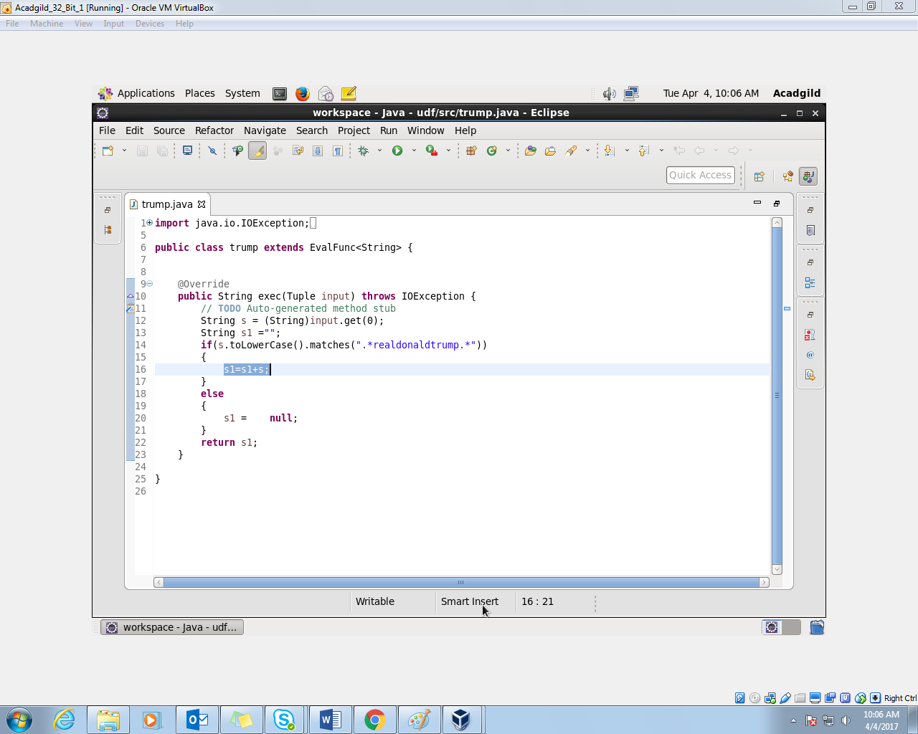

Pig Script:

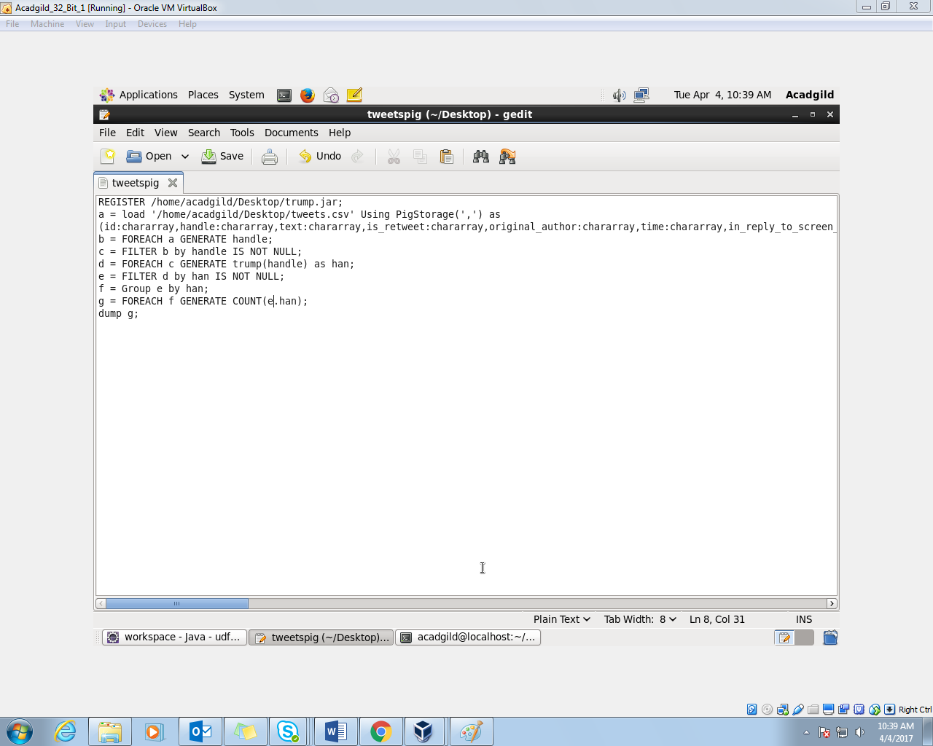

Running the Script in local mode:

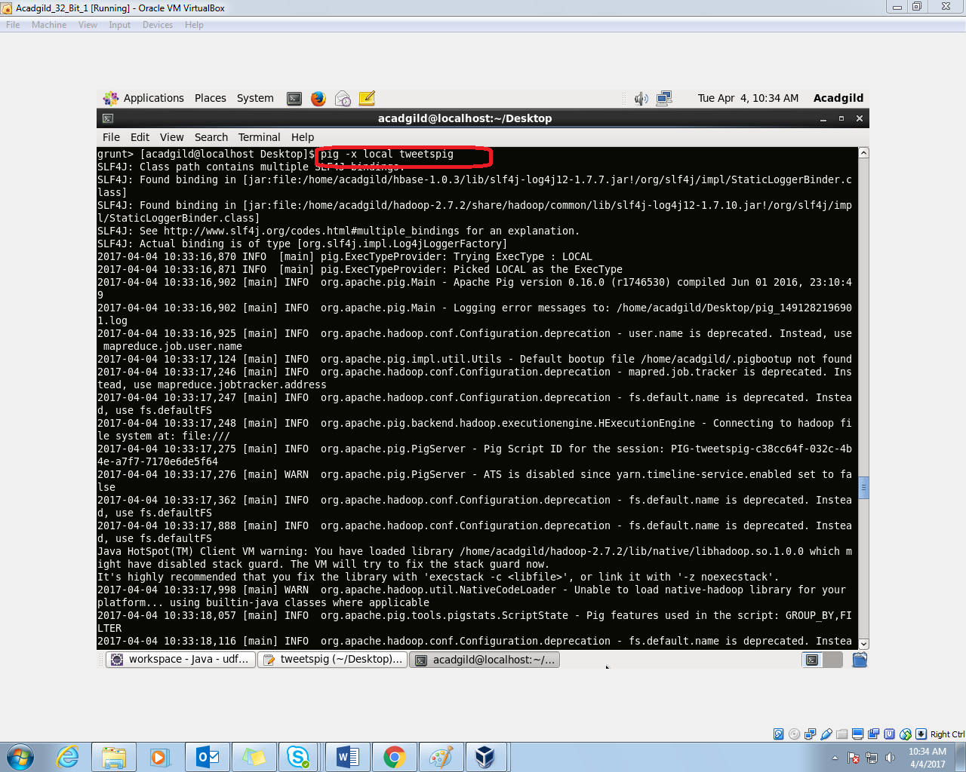

Output:

